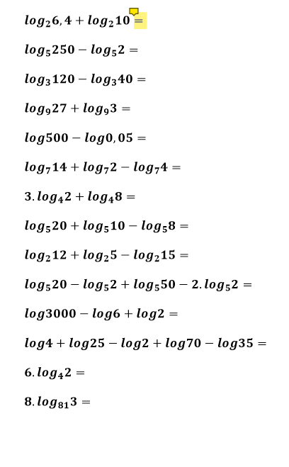 **Log264 = 26 = 6**

**Log5125=53=3**

**Log33=31=1**

**Log981=92=2**

**log10000=104=4**

**log77=71=1**

**log48+log48=log464=43=3**

**log525=52=2**

**log24=42=2**

**log5125=53=3**

**log1000=103=3**

**log100=102=2**

**log426=log464=43=3**

**log8138=log816561=812=2**